|  |  |
| --- | --- |
|  | **YEAR 12 MATHEMATICS SPECIALIST**  **SEMESTER ONE 2016**  **PRACTICE TEST 1: Complex Numbers** |

Name: _______________________

Time: 60 minutes Mark /55

Mostly calculator free – scientific OK.

### [7 marks]

#### Complete the table:

|  |  |  |
| --- | --- | --- |
|  | Rectangular form | Polar form |
| *z* |  |  |
| *w* |  |  |

[2]

#### Determine:

##### 

##### 

##### 

[5]

* 1. [7 marks]

Given that  is one of the cube roots of a complex number *z*, determine:

1. 

[1]

1.  such that 

[2]

1. The other two cube roots of *z*

[2]

1. A solution for *w* in the equation 

[2]

* 1. [12 marks]

For  , determine:

1. 

[1]

1. the remainder when  is divided by 

[1]

1.  if  [1]
2.  [1]
3. two solutions to  [2]
4. all solutions to  [4]
5.  in a fully factored form (as a product of 4 linear terms) [2]
6. [14 marks]

a) Convert both  and  into polar form.

[2]

b) Hence express  in the form .

[2]

c) Determine the smallest positive integer *n* for which  is purely imaginary and state the value of  for this particular *n* value.

[3]

d) Solve for *w* given that  and plot your solutions on the Argand diagram below.

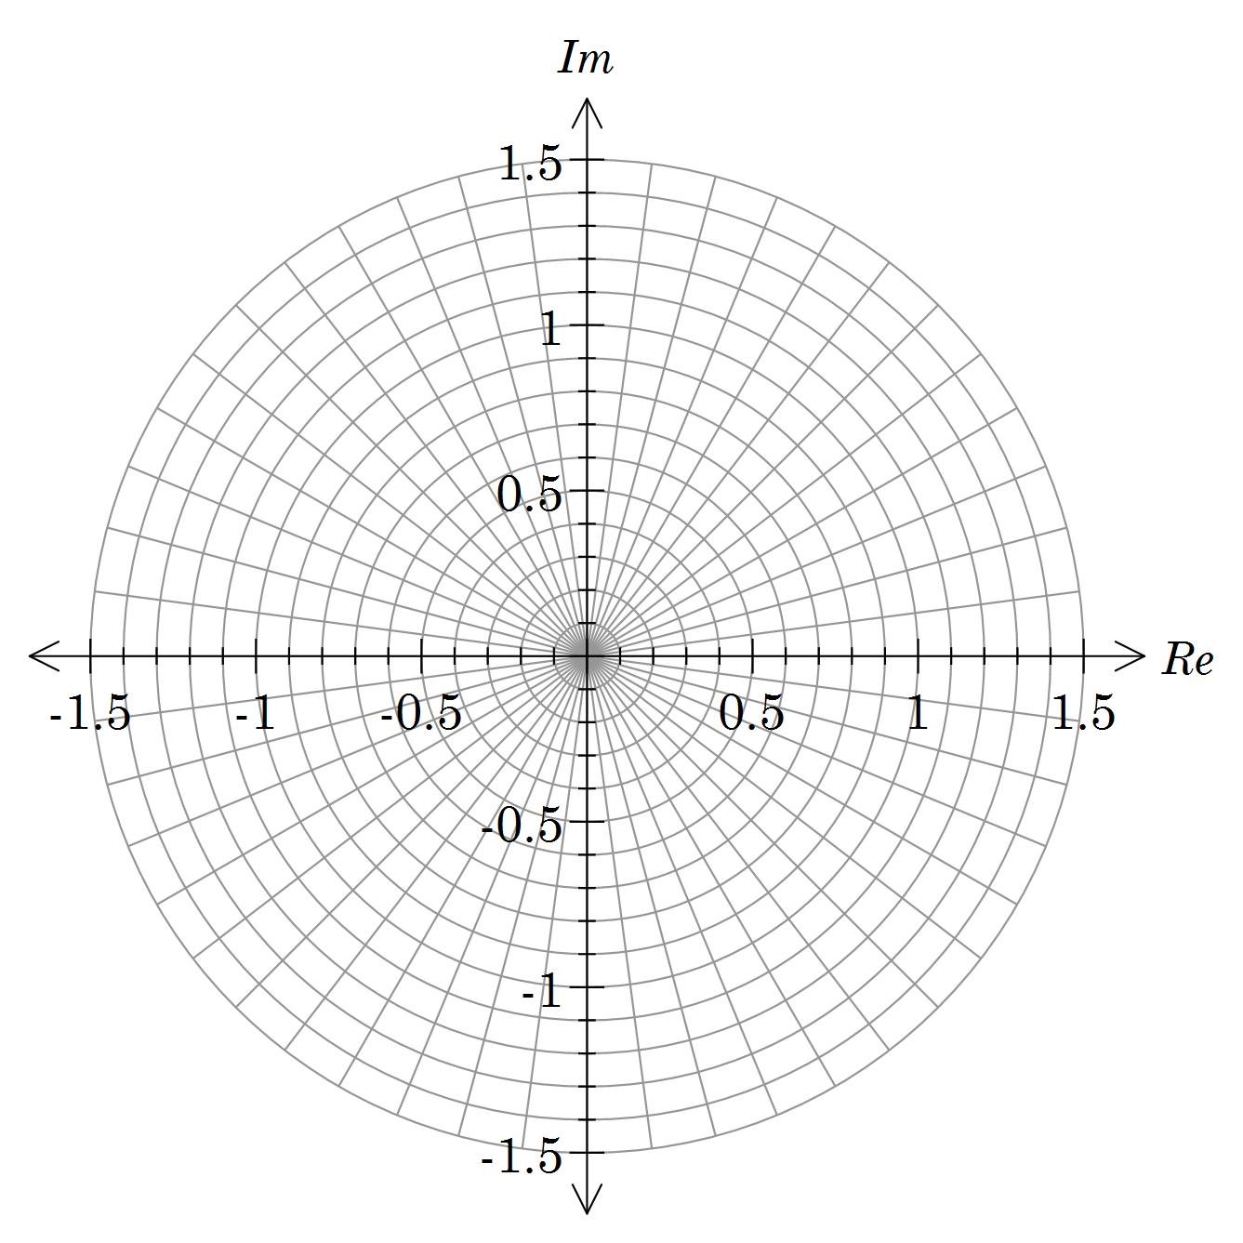

[4]

e) If  represents the *n*th solution to the equation in d) moving anticlockwise around the Argand diagram, explain the geometric meaning of  and determine its value.

[3]

* 1. [8 marks]

1. Sketch neatly the locus of *z* where  , then determine the Cartesian equation of the resulting sketch.

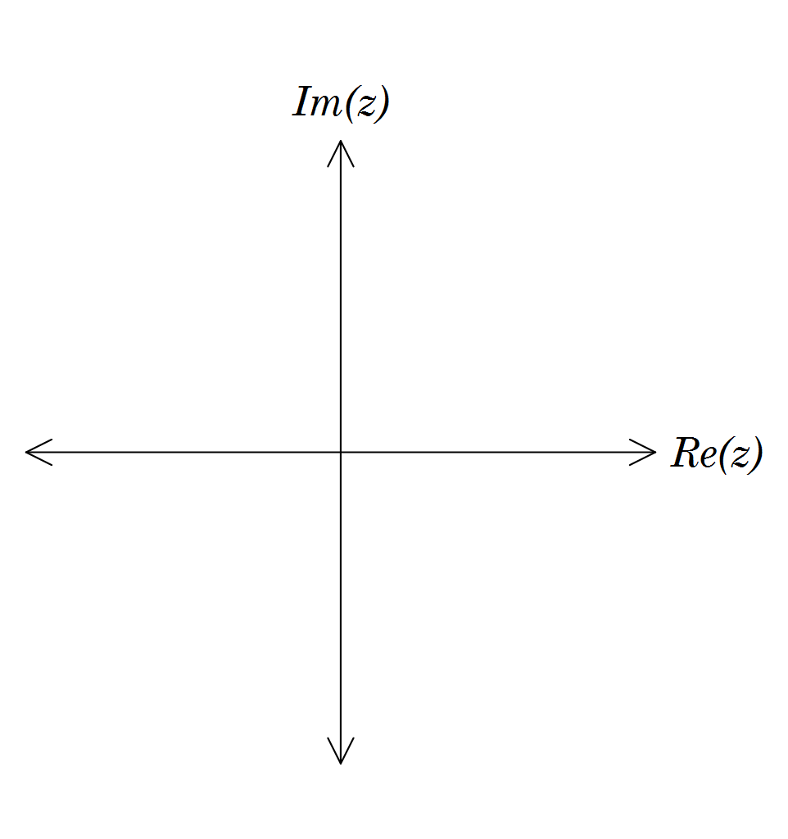

[3]

1. Write an inequality that describes the locus of *z* shown below.

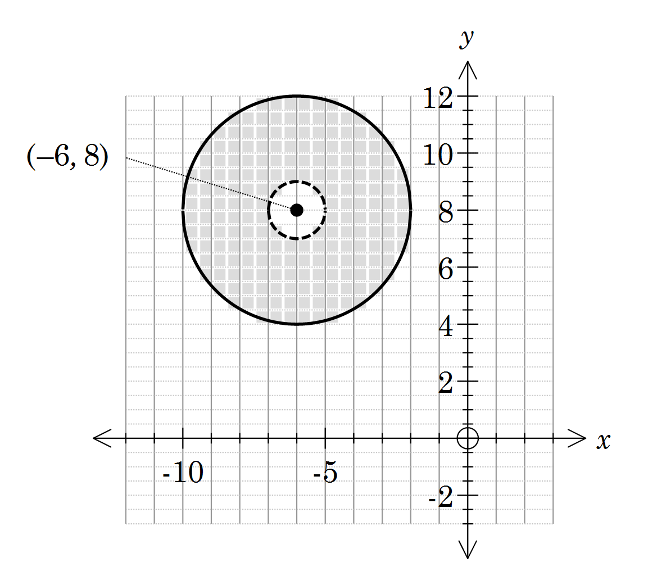

[3]

1. For the locus shown in b) determine the minimum value of .

### [7 marks]

#### Sketch the region in the Argand diagram below that simultaneously satisfies the inequalities:



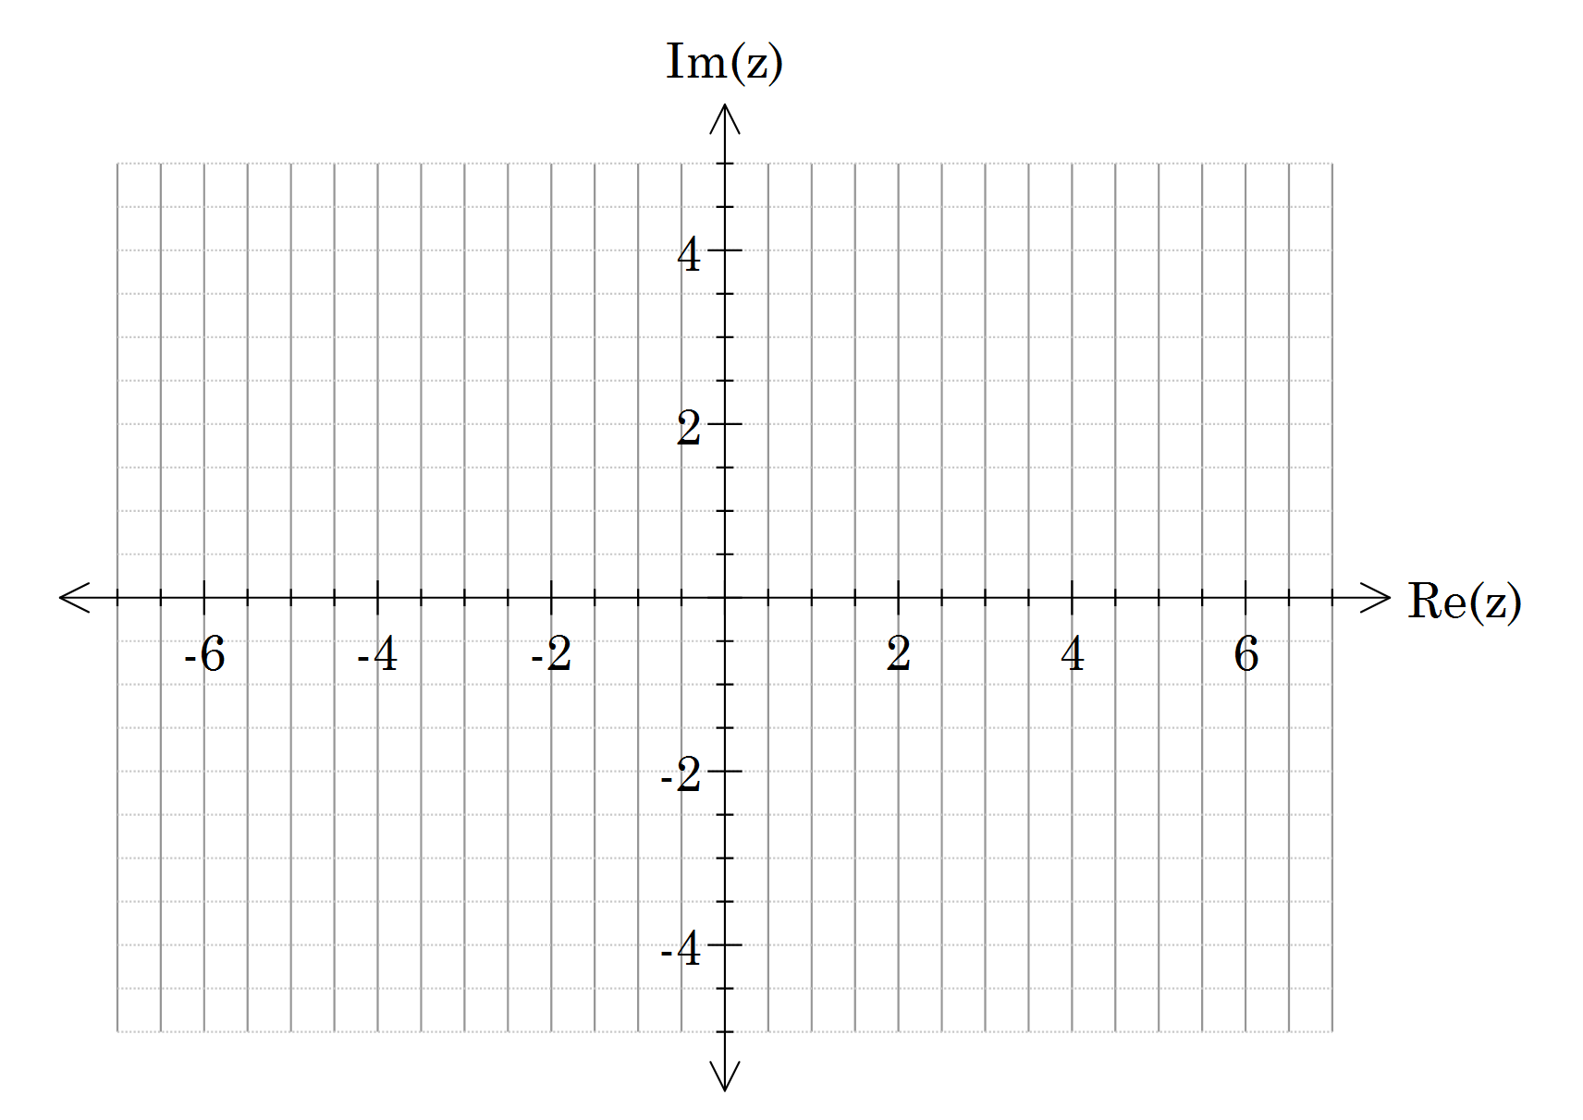

[5]

#### For , prove that

[2]